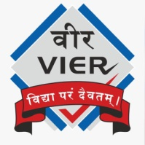 | Vadodara Institute of Engineering  Details of Industrial Visit

Name of Industry / Organization | Rishabh Software, Vadodara
Address of Industry/Organization | Plot 66, Padra road, beside Sigil India, Atladara, Vadodara, Gujarat 390012
 | Gujarat 390012
Date & Day of Industrial Visit | 16/08/2024, Friday
Timing of Industrial Visit | 1 day
Semester | 7th
Discipline | Computer/IT
Academic Year | 2024-25
Nos. of Students Present | Students(62) Faculty (5)  Total (67)
Names of Faculties accompanied to students | Prof. Jemisha Patell  Prof. Pratik Kahar  Prof. Dwiti pandya  Prof. Sana Kothiwala  Prof. Rikita Gohil
How this visit was useful to students for strengthening their practical understanding? | It was a great and enjoyable experience for our students. All students have learnt about current technologies applications provided by technical trainer rishabh software. They provide internship also to the students, So our students got the information about the internship.

Prof. Jemisha Patel
HOD CE/IT Department
